**Chapter 12 GROWTH THEORY Questions**

1. An example of physical capital is

* 1. a college degree.
  2. a factory.
  3. a skilled worker.
  4. oil.
  5. political stability.

2. The basic premise of early growth theory was that the rich countries were those with more

* 1. workers.
  2. laws.
  3. physical capital.
  4. natural resources.
  5. education.

3. The relationship between the growth rate of real gross domestic product (GDP) and the growth rate of real investment is

* 1. positive.
  2. negative.
  3. unpredictable.
  4. nonexistent.
  5. negative at low levels of real GDP and then positive at higher levels of GDP.

4. Country X has a higher growth rate of real investment than Country Y. You might expect Country X to also have

* 1. a higher growth rate of real gross domestic product (GDP).
  2. the same growth rate of real gross domestic product (GDP).
  3. a lower growth rate of real gross domestic product (GDP).
  4. a lower level of net investment.
  5. a lower level of depreciation.

5. In the Solow growth model, ________ measures the labor input in terms of the physical number of workers and the knowledge and skills embodied in those workers.

* 1. natural resources
  2. human capital
  3. technology
  4. physical capital
  5. output

6. In the Solow growth model, human capital will increase if

* 1. there is a decrease in the number of workers.
  2. workers become better educated and more skilled.
  3. there is an increase in production.
  4. real wages decrease.
  5. there is a decrease in physical capital.

7. In a population, not all workers have a high school diploma. Suppose the size of the labor force increases, but a smaller percentage of the labor force has a high school diploma. It is reasonable to expect that having a larger labor force will ________ the human capital input and having a smaller percentage of the labor force with a high school diploma will ________ the human capital input.

* 1. decrease; increase
  2. decrease; decrease
  3. increase; decrease
  4. increase; have no effect on
  5. increase; increase

8. The key assumption of the Solow model is

* 1. increasing returns.
  2. diminishing returns.
  3. constant returns.
  4. negative returns.
  5. random returns.

Use the following graph to answer the next five questions.

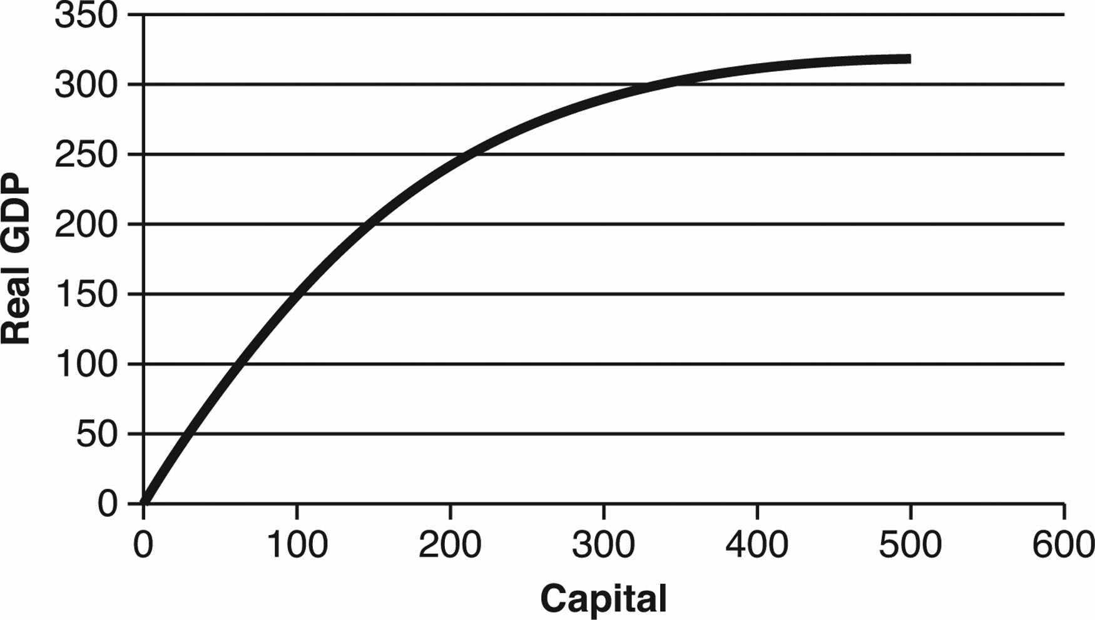

9. If capital is increasing, then

* 1. the production function will shift upward.
  2. the production function will shift downward.
  3. there is an upward movement along the production function.
  4. there is a downward movement along the production function.
  5. there is an upward shift of the production function and an upward movement along the production function.

10. If net investment is positive, then

* 1. the production function will shift upward.
  2. the production function will shift downward.
  3. there is an upward movement along the production function.
  4. there is a downward movement along the production function.
  5. there is an upward shift of the production function and an upward movement along the production function.

11. If this country experiences a war that decreases capital, then

* 1. the production function will shift upward.
  2. the production function will shift downward.
  3. there will be an upward movement along the production function.
  4. there will be a downward movement along the production function.
  5. there will be no effect on the production function.

12. If net investment is negative, then

* 1. the production function will shift upward.
  2. the production function will shift downward.
  3. there will be an upward movement along the production function.
  4. there will be a downward movement along the production function.
  5. there will be no effect on the production function.

13. When moving up along the production function, the marginal product of capital will eventually

* 1. increase.
  2. decrease.
  3. first decrease and then increase.
  4. first increase and then remain constant.
  5. remain constant.

14. Diminishing marginal product occurs when the marginal product of an input ________ as the quantity of the input ________.

* 1. increases; remains constant
  2. remains constant; increases
  3. decreases; increases
  4. increases; decreases
  5. decreases; decreases

15. If a firm experiences diminishing marginal productivity, the marginal product of physical capital will ________ when the amount of physical capital is ________.

* 1. increase; increased
  2. increase; decreased
  3. decrease; decreased
  4. decrease; increased
  5. increase; constant

Use the following production function to answer the next FOUR questions.

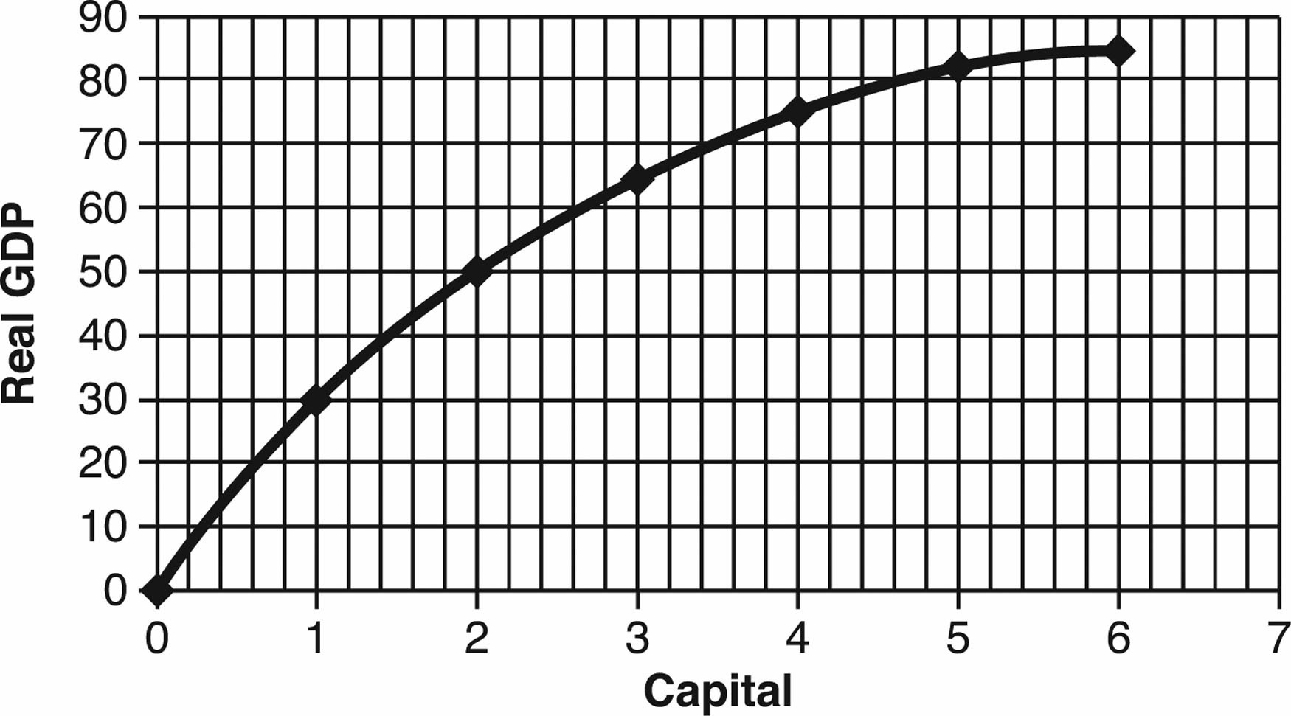

16. This production function exhibits diminishing returns to capital for

* 1. all units of capital after the first.
  2. no units of capital.
  3. all units of capital after the second.
  4. all units of capital after the third.
  5. all units of capital except the sixth.

17. When the second unit of capital is hired, the marginal product is equal to

* 1. 10.
  2. 20.
  3. 30.
  4. 40.
  5. 50.

18. The marginal product of the third unit of capital is ________ and the marginal product of the fourth unit is ________.

* 1. 15; 10
  2. 25; 40
  3. 30; 20
  4. 50; 35
  5. 65; 75

19. The marginal product of the fifth unit of capital is

* 1. negative.
  2. greater than the fourth unit.
  3. the same as the fourth unit.
  4. less than the fourth unit.
  5. zero.

20. Suppose Florida was operating at its steady state when a major hurricane hits and destroys significant amounts of physical capital. All else being the same, Florida's real gross domestic product (GDP) will ________ in the short run, and real GDP will ________ in the long run.

* 1. decline; be permanently lower
  2. decline; return to the steady state level
  3. be unchanged; decline
  4. increase; decrease
  5. decline; end up higher than the original level

21. An economy is in the steady state if

* 1. there are no diminishing returns.
  2. net investment is positive.
  3. capital grows at a constant rate.
  4. depreciation is zero.
  5. investment equals depreciation.

22. The Solow model implies that an economy will reach a steady state because

* 1. there is a shortage of skilled workers.
  2. people run out of new ideas.
  3. there are limited natural resources.
  4. physical capital loses its value over time.
  5. the marginal product of capital decreases.

23. According to the Solow model, an economy should build

* 1. as much capital as possible.
  2. more capital as long as the marginal product is positive.
  3. more capital as long as doing so will increase output.
  4. more capital as long as the extra benefit is at least as great as the extra cost.
  5. more capital as long as there are no diminishing returns.

24. According to the Solow growth theory, developing nations will catch up to the developed nations

* 1. if developing nations become more politically stable.
  2. because for developing nations, the marginal productivity of capital is higher when they use lower levels of capital.
  3. if developing nations provide jobs for unemployed workers.
  4. because developing nations have more natural resources.
  5. if developing nations devote more resources to education.

25. Considering the growth experience for all countries in the world,

* 1. there is evidence that growth has slowed in the developed countries.
  2. there is evidence that many developing countries are catching up.
  3. there is evidence of poor countries catching up and of growth in wealthier countries slowing down.
  4. there is little evidence of catching up by the poor countries or of the slowing down of growth in the wealthy countries.
  5. the predictions of the Solow growth model have been validated.

26. According to the Solow growth theory, the developing nations

* 1. will never be as wealthy as the already-developed nations.
  2. should eventually be as wealthy as the already-developed nations.
  3. will eventually be wealthier than the already-developed nations.
  4. will always grow more slowly than the already-developed nations.
  5. will never converge at a steady state.

Use the following graph to answer the next four questions.  
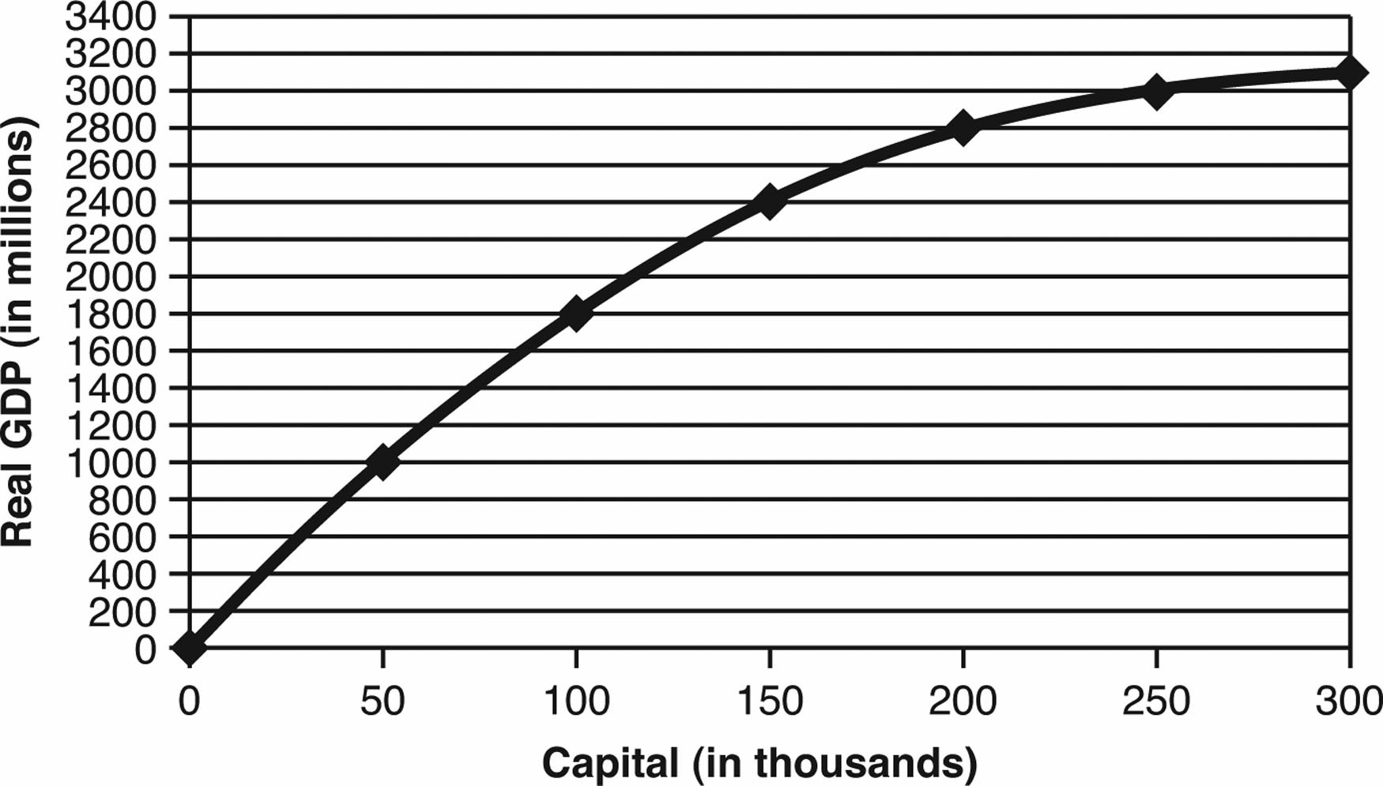

27. Suppose a major tornado hits the Midwest and destroys significant amounts of physical capital. All else the same, in the short run, we can expect the marginal product of capital to ________ and investment will ________.

* 1. increase; increase
  2. remain unchanged; increase
  3. decrease; increase
  4. remain unchanged; decrease
  5. decrease; decrease

28. A good economic model

* 1. is extremely complex and inflexible.
  2. is not related to real-world observations.
  3. never needs to be reevaluated.
  4. is simple, flexible, and useful for making accurate predictions.
  5. is a perfect replication of reality.

29. A technological advancement will cause

* 1. an upward movement along the production function.
  2. a downward movement along the production function.
  3. the production function to shift upward.
  4. the production function to shift downward.
  5. no effect on the production function.

30. New technology makes capital ________ and real per capita GDP will ________.

* 1. more productive; remain unchanged
  2. more productive; increase
  3. more productive; decrease
  4. less productive; increase
  5. less productive; decrease

31. How will technological advancement impact the steady state level of capital in the Solow growth model?

* 1. It will have no effect.
  2. It will increase the steady state level of capital.
  3. It will decrease the steady state level of capital.
  4. It will increase the steady state level of capital in the short run but not in the long run.
  5. It will increase the steady state level of capital in the long run but decrease the steady state level in the short run.

32. Modern (new) growth theory and the Solow growth model are both based on the importance of

* 1. endogenous technological change.
  2. skilled labor.
  3. the production function.
  4. natural resources.
  5. exogenous technological change.

33. All of the following are examples of positive institutions EXCEPT

* 1. private property rights.
  2. the flow of funds across borders.
  3. restrictions on trade and closed markets.
  4. efficient taxes.
  5. stable money and prices.

34. Which of the following describes the correct direction of causality?

* 1. economic growth → growth-friendly incentives → growth-friendly institutions
  2. growth-friendly incentives → economic growth → growth-friendly institutions
  3. growth-friendly institutions → growth-friendly incentives → economic growth
  4. economic growth → growth-friendly institutions → growth-friendly incentives
  5. growth-friendly institutions → economic growth → growth-friendly incentives

35. Which of the following policies would be advocated by modern growth theory?

* 1. restrict private property rights
  2. limit the flow of funds across borders
  3. discourage international trade
  4. promote political stability
  5. excessively high tax rates

36. Sustained economic growth is primarily caused by

* 1. advances in technology.
  2. employing more people.
  3. building new roads and factories.
  4. increases in government spending.
  5. discovering more natural resources.

37. According to modern (new) growth theory, the primary reason why countries around the world have not converged at the same level of income is that they

* 1. do not have access to the same resources.
  2. do not have the same level of capital stock.
  3. have different numbers of people.
  4. have different institutions.
  5. do not have access to the same technology.

38. A coffee shop can make 100 cups of coffee with one espresso machine and 180 cups of coffee with two espresso machines. The marginal product of the second espresso machine is

* 1. 1.8 cups of coffee.
  2. 18 cups of coffee.
  3. 40 cups of coffee.
  4. 80 cups of coffee.
  5. 280 cups of coffee.

39. According to the Solow growth model, investment in developing countries should yield relatively ________ returns, and should lead to ________ capital in developing nations.

* 1. higher; more
  2. higher; less
  3. lower; unchanged
  4. lower; more
  5. lower; less

40. The adoption of efficient institutions will

* 1. shift a nation’s production function upward.
  2. shift a nation’s production function downward.
  3. cause an upward movement along the nation’s production function.
  4. cause a downward movement along the nation’s production function.
  5. not affect a nation’s production function.

41. What does it mean to say capital is the result of economic growth rather than it being the cause of economic growth?

42. Juan has been doing some research on countries in Europe and Africa. Juan has observed that European countries are wealthier and have a higher percentage of workers who are college educated. Therefore, Juan concludes that sending more Africans to college will increase economic growth and wealth in Africa. Discuss the validity of this conclusion.

43. Five college students share a house. As the number of computers owned by these students increases from one to five, what happens to the total number of hours they spend using a computer? As each computer is purchased, what happens to the marginal product, in terms of additional hours spent using the computer?

44. Why does the Solow growth model predict that per capita gross domestic product (GDP) levels across nations will equalize as nations approach the steady state?

45. What policy prescriptions follow from the Solow growth model?

46. Why are institutions so important for economic growth?

47. According to the Solow growth model, which countries in the world should have reached a steady state? Does the model suggest there should be convergence among all countries, such that the poor countries will catch up to the rich countries?

48. An island nation is in a steady state. A major hurricane passes over the nation and destroys half of its capital stock. What happens to gross domestic product (GDP), investment, and net investment in the short run and the long run? Explain.

49. In 1980, the United States was wealthy, but China was poor. Yet, since 1980, growth rates in China have exceeded growth rates in the United States. According to the Solow growth model, why has China grown faster than the United States over this time?